My journey to Myanmar in Oct. – Nov. 2015. by Tony Suckla

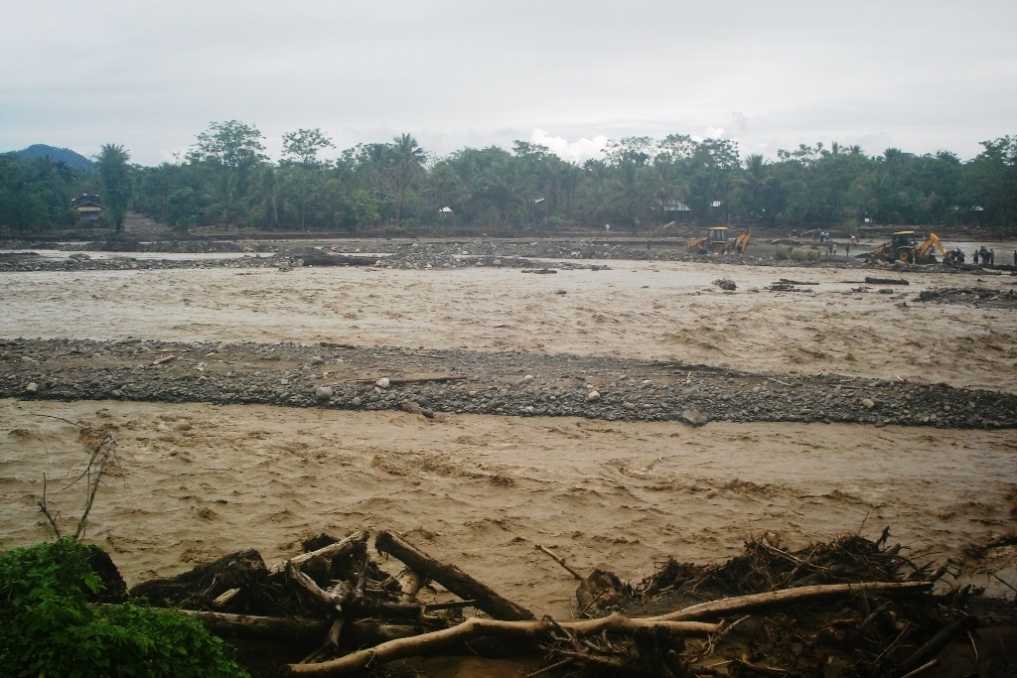
I started my journey to Myanmar on Oct. 11 by catching a 17 hour train from S. India to Kolkata; from there I caught a flight to Imphal, Manipur, in northeast India. Then I rented a Tata Sumo that took me to a place called Moreh that is a border town of India. I crossed the border on Oct. 13 and stayed in Tamu, Myanmar. The rain was very heavy and the bridges were washed out in many places and so it took a whole day to travel to Kalaymyo where I was to meet Pas. John Mark. During the trip to Kalaymyo there were several places where the mud was very deep and I had to off my shoes and go barefoot, then a boat or raft would take me over the river. I was carrying a laptop and a big suitcase and I was praying that I could get over without losing anything.
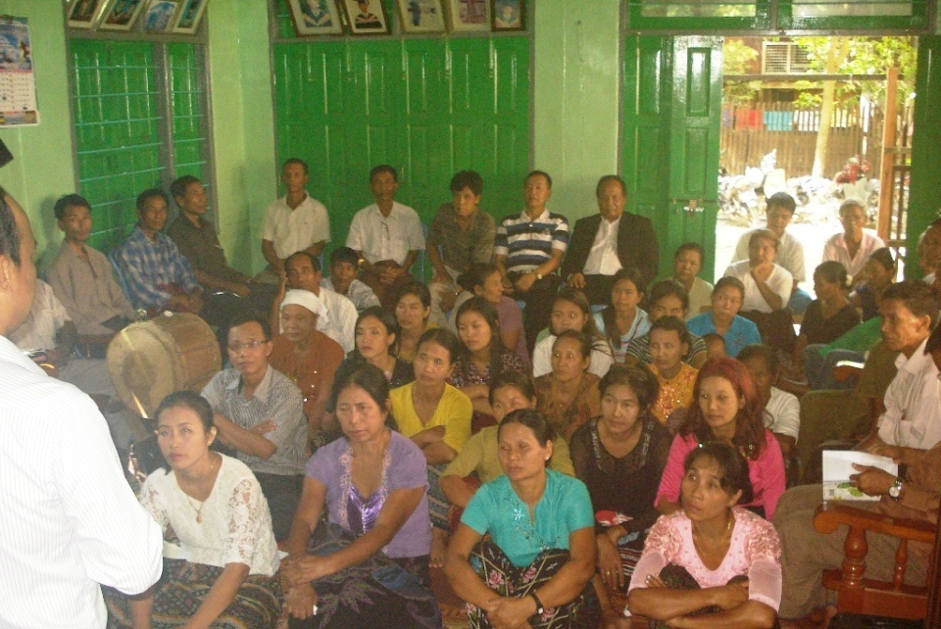
When I got to Kalaymyo I had to stay in a lodge that costs 25 dollars per night. This is a very high price by Myanmar standards. And is about three times what a local would pay. But the government rules in Myanmar do not allow any foreigners to stay in homes of locals. You have to stay in government approved hotels and pay higher prices than the locals.
Pastor John Mark met with me and arraigned a three day meeting in his house with the various believers in that area where I would speak morning and evening on the Torah oriented Messianic faith. There were about 50 in attendance at the meetings. I met one lady at the meetings that was immersed by Jacob O. Meyer in the name of Yahshua Messiah in 1983. (She said she went to Yangon the capital and that Jacob immersed her there. There was a pastor Joel that was preaching the Sacred Names in her northwestern area of Myanmar). (see picture below). The meetings went well with many questions being asked and answered. I hope to go back again someday and keep a feast with them. Pastor John Mark knew English and could translate in the local Chin language. He had attended a theological college in Bangalore S. India where he met a friend of mine named Ben Yah who taught him the basics of the Torah oriented faith of Messiah Yahshua.
Kalaymyo had recently suffered a flood and there was much destruction at that time but they had cleaned up fairly well.
John Mark is married and has two children, he supports his family by buying items in China, India, Thailand and bring them into Myanmar and reselling at a higher price. After Sabbath he helped me catch a bus to Mandalay and then he had to go to China for his work.
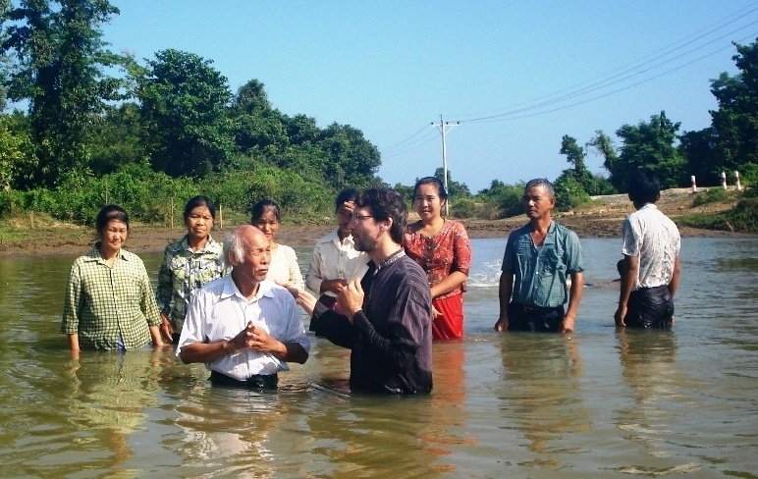
In Mandalay, I met with a Pastor Lazum Brang that had been writing to me for about ten years. Lazum helped me book a train for both of us to go north to the state of Kachin. Kachin is a state of India that borders China. There is at present a 50+ year civil war going beween the Kachin Independent Army and the Burmese government. The state contains about 1.2 million people but there are about 125,000 refugees that have been pushed off their land and forced to migrate somewhere else. Even Pastor Lazum and his family were refugees and displaced from their homeland when he was a young man. Pastor Lazum is seventy years old and is full time in the ministry. Pas. Lazum speaks about fifteen languages fluently including English. He first married when he was fifty and now has four daughters, a fifth daughter died. He was very active and healthy, I had a hard time keeping up with him. The food they eat is generally rice, legumes and vegetables, some fruits, some meats. I noticed that no one I stayed with drank milk. But I also noticed that with every meal the people would have a bowl of boiled greens. Pas. Lazum, heard about the Sacred Names about 15 years ago and somewhat followed them. I had a four day meetings with Pas. Lazum and congregation and eight people took immersion in Yahshua Messiah’s Name. Pas. Lazum told me that he had already been baptized in Yesu Christos name and asked if that was enough. I told him that in Yeshayah 26:3 and 12:2 that Yeshayah said “Yah Yahweh” was his salvation and that a son will always take the surname of the father. I advised that being that he is a pastor it was best for him to set a good example, he accepted, and so he and seven others took immersion in the name of Yahshua Mashiach. In Myanmar, as in most places of Asia, the surname or family name of a person is always written first and then the given name. So when they saw “Yah Yahweh” in Yeshayah 12:2 they reasoned that Yah was the surname. And that this is the Name Yahshua was referring to when He said, “I have come in my Father’s Name”, John 5:43. I know there is a spiritual understanding to that verse, but I believe there is a literal understanding as well. Personally, I see the prominent Yah syllable in HalleluYah, many Hebrew names, and the short form Yah used about 50 times in the OT. I cannot see any reason why it should be changed to Yeh, Ye, Yo, etc…
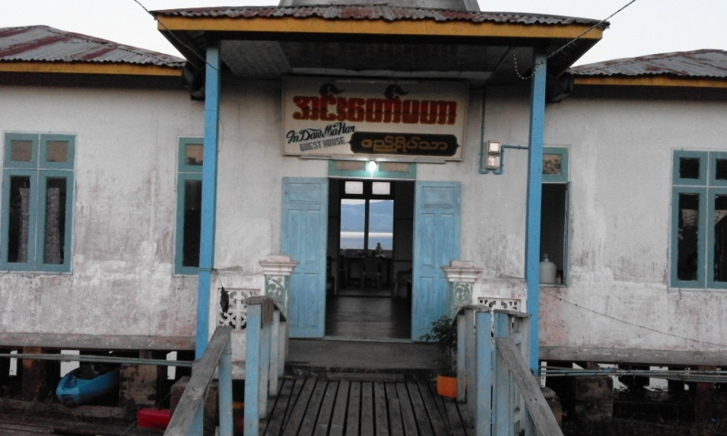
While I stayed in Kachin state, there were no lodges that were government approved nearby Lazum’s small prayer hall. So I had to stay about an hour away by motorbike and I had to be at the lodge before sundown. So I could not have night meetings in Kachin. The lodge I stayed at was on Lake Indawgyi. After the baptisms on Sunday Lazum and I went to Myitkyina, the capital of Kachin. I met with several of his friends, relatives and believers and encouraged them in the truth.
Lodge on Lake Indawgyi
In Myitkyina I took a train back to Mandalay and kept Sabbath there at a SDA church, the service was all in Burmese, but a few, including the pastor, knew English and I distributed some literature to them. The trains in Myanmar are like riding a very bumpy swaying boat. I thought the train was on the verge of falling over several times. Trying to use the bathrooms in that condition was very difficult, I basically went in the toilet and pissed all over the walls and left.
From Mandalay I took a shared auto to the border town of Tamu where I had previously entered, and then the next day I crossed the border to Moreh, India on Nov. 3 and took a van to Imphal.
While in Myanmar I was treated very nicely and with courtesy. Myanmar is generally a Buddhist country but the areas of Kalaymyo and Kachin state are about 90% Christian. In Kachin the government of Myanmar only controls one third of the state the other two thirds is controlled by the Kachin Independent Army(KIA). Foreigners are not allowed by the Myanmar government into the area’s controlled by the KIA. In Kachin state it is not allowed to build any new Assembly halls, old ones can be renovated but no new ones can be built. It is not allowed for the Kachin people to teach their own native language of Jingpo in the schools. These restrictions and other governmental controls have caused great dislike of the Kachin for the Myanmar government.
When the British ruled Myanmar, English was promoted in all the schools so today many educated older people can speak English, but when the Burmese took over from the British they promoted Burmese and thus today few younger people can speak fluent English. I saw a great need for an English medium School in Myanmar like the one we have in India. I encouraged both John Mark and Pas. Lazum to start English Medium Schools and they agreed that there is great need and would try in the future.
Myanmar has been ruled militarily since 1962, but on Nov. 8 this year they finally allowed a democratic election to take place. The National league for democracy(NLD) was elected that was founded by Aung San Suu Kyi. There were about ten parties that contested the vote but the NLD won with about 60% of the vote. The military still retains a strong position in the government because of the Constitution that they wrote.
I found the Myanmar people that I visited to be very open spiritually and I see a great future for the truth to spread there. At present a foreigner can only obtain a 28 day visa as a tourist, I have heard that this can be extended by one month for a price, and through local agents one can obtain 90 day business visas. I enjoyed my stay in Myanmar and hope for future promotion and growth of the truth there.

Tony B. Suckla Nov. 21, 2015

Pastor Lazum Brang and assembly members taking immersion
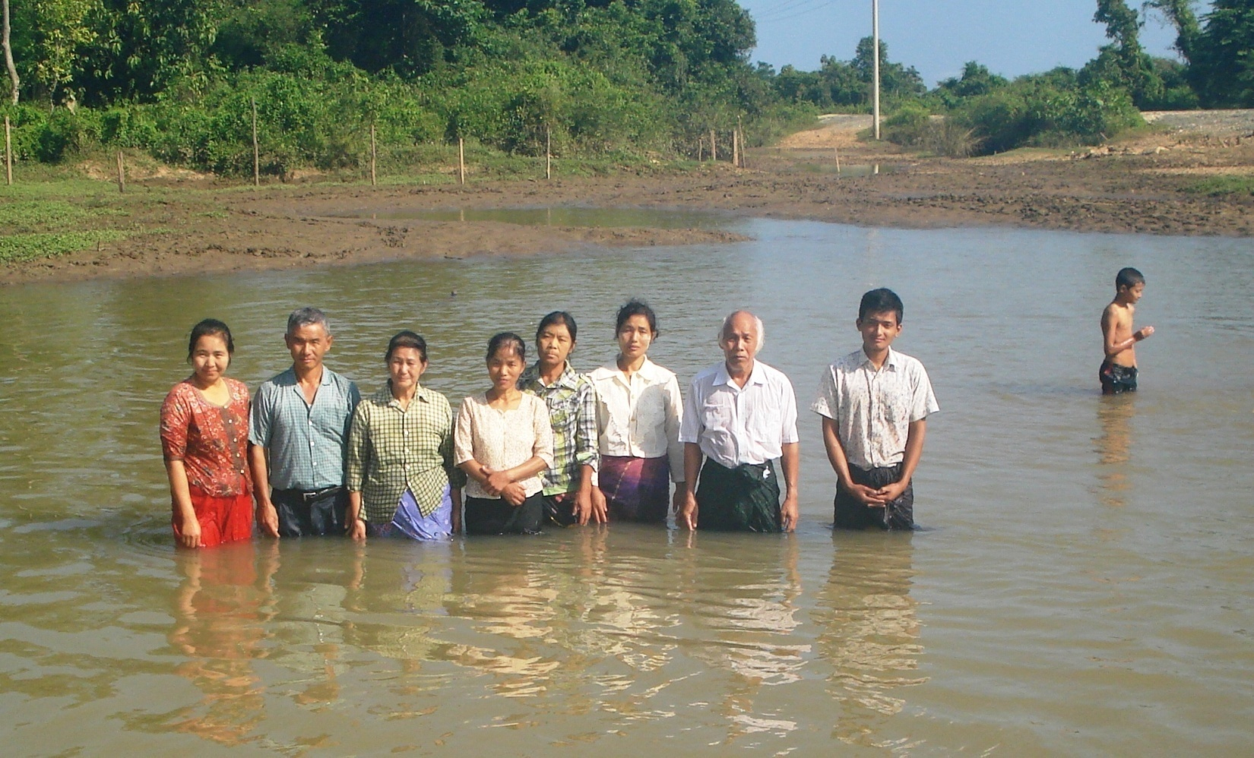

This lady was immersed by Jacob O. Meyers in 1983
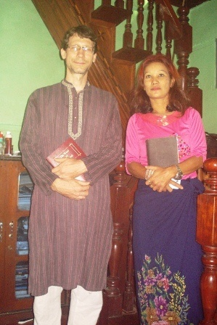

Pastor John Mark and family, Oct. 2015
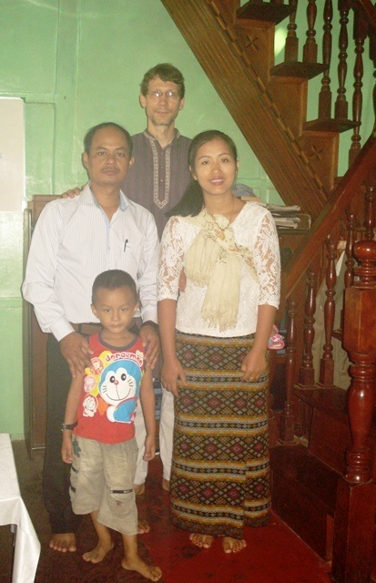

Common Myanmar dish, quail egg curry, rice, pasta salad, boiled greens
