My ten day trip to Kenya, Africa. by Tony B. Suckla
In about the year 2005 I was in contact with some brethren from Kenya, Africa and I had planned on visiting them at that time, but some reasons prevented me from going. About 2 years ago I came in contact with brother Wilson Koech from Kenya that was from Church of God background and he told me that he wanted to take immersion in the Name of Yahshua Messiah. I had met Pastor Wilson Koech through br. Mike Abbaduska in Illinois. So after two years I made plans to visit Wilson April 1-10, 2019 so that he could be ready for Pesach.
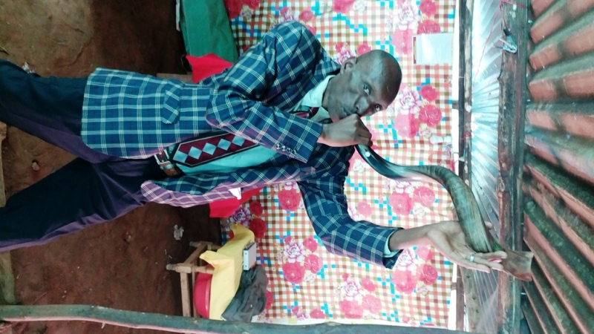
On April 1 I left Hyderabad, India and flew to Nairobi, Kenya; upon arriving I met Pastor Koech at the airport and he conducted me to a lodge as it was about 10pm. That night I realized I left a Shofar in India that I had planned on bringing for the Rosh Chodesh(new moon) of Abib. So I got online and I found a Messianic Jewish Congregation in Nairobi called “Shofar House”. They put me in touch with a man who had some shofars which were made in Ysrael. So I bought one for pastor Koech. We later viewed the new moon on April 6, 2019 in the evening and had meetings that Saturday night and the following Sunday morning of April 7.
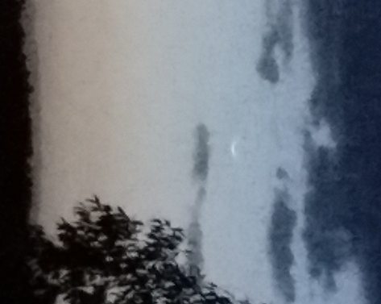
New Moon as sighted from Bomet, Kenya, Africa on April 6, 2019
Pastor Wilson Koech trying to sound the shofar that I gifted to him.
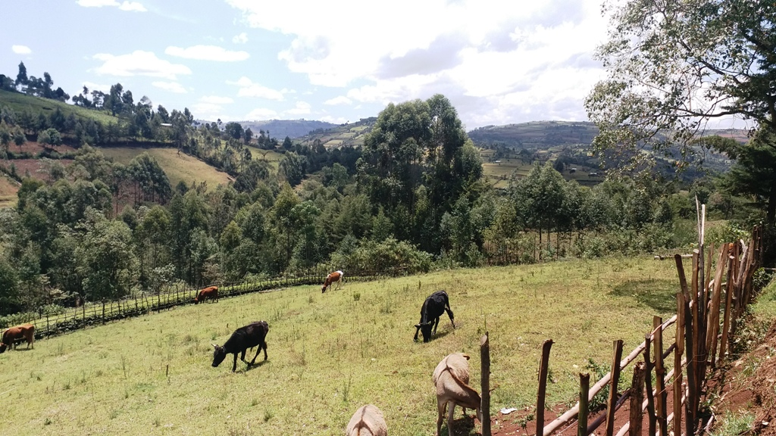
I was surprised by the climate of the area I was in. Even though it is right on the equator it is about 1 mile high in elevation so it was a very pleasant environment of about 55˚F at night to a high of about 85˚F during the day. I was in the highlands of Kenya which is a mountainous area that reminded me of the lowlands of the Himalayas in Nepal. I was also surprised to see that so many people could speak fluent English. The national language of Kenya is Swahili but the area that I was in spoke a language called Kalenjin. There are about 50 million people living in Kenya but only about 1.6 million speak the language of Kalenjin.
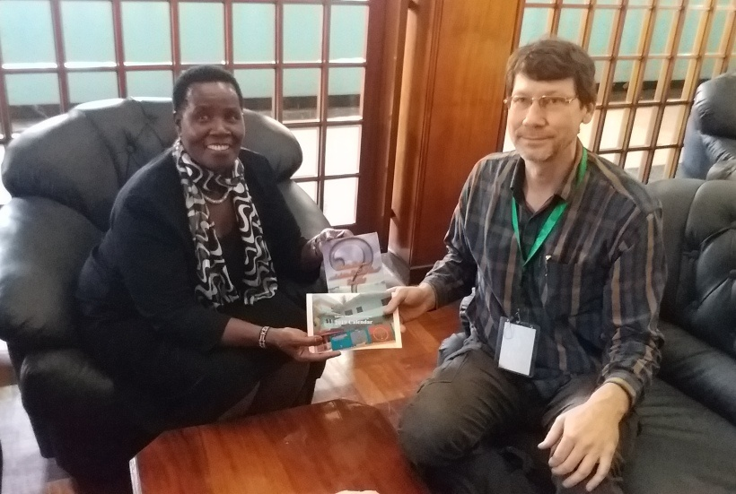
The day after I arrived in Kenya while still in Nairobi Pastor Wilson took me to see the National Parliament of Kenya and I met briefly with his local representative, who was a distant relative of his and gave her some literature about the Names of the Father and Son.

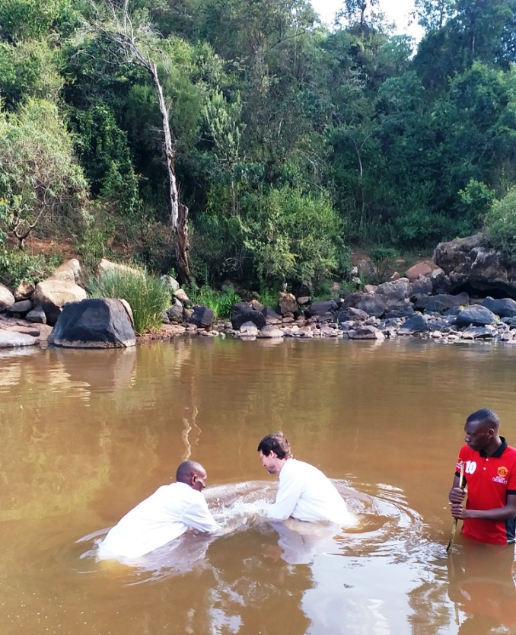
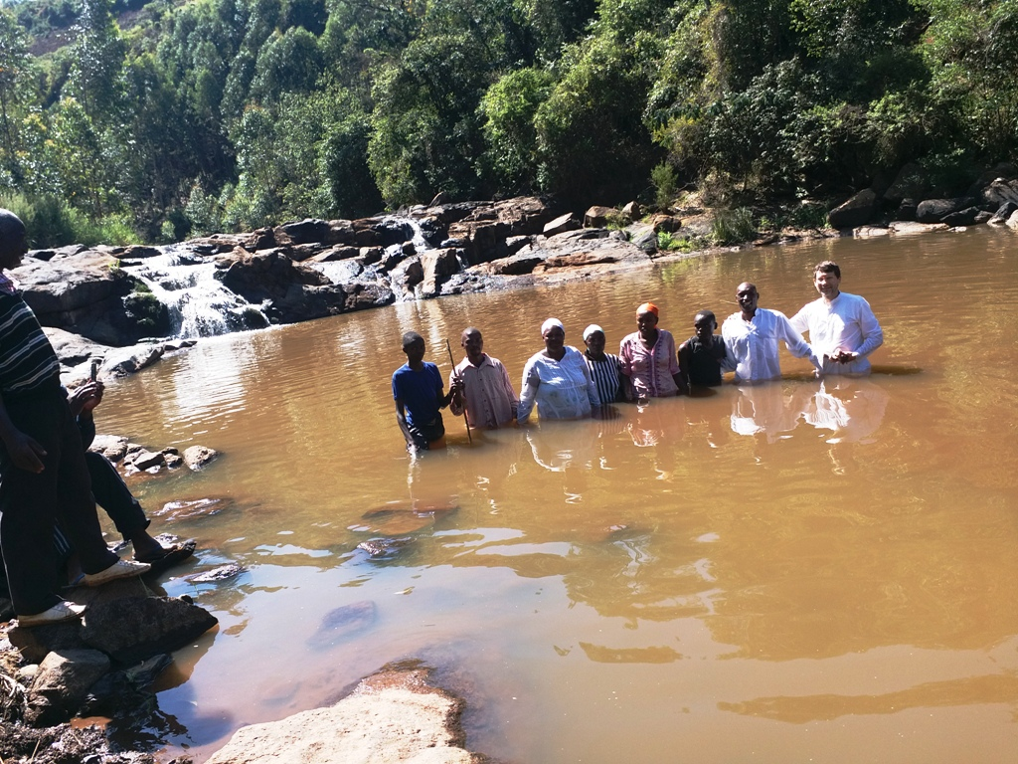
While still in Kenya near the parliament building there were many soldiers marching in red uniforms so I pulled out my cell and took a photo. Immediately one soldier with a machine gun comes to me and asks my cell phone, he deleted the photos and warned me, then gave the cell back to me. On April 3 we went to a river and Pastor Wilson Koech was immersed in the Name of Yahshua Messiah. Throughout my stay in Kenya 12 people took immersion in Yahshua Messiah’s Name including Pastor Wilsons wife, son, and a few elders and members of his congregation.

In Kenya all of the people that I met were Christian believers and there seemed to be certain unity amongst the people. I stayed for about five days at the house of Pastor Wilson in the Bomet area. In that area there is no electricity so most people will have Solar panels that collect the energy in large batteries. There is also no television, landline telephones, or running water. There was a cell phone tower from which a weak data and internet signal can be accessed. They had simple outhouses built for toilets and when I bathed it was with about two gallons of water or less. Because water is so scarce they will not use a cup to pour the water during bathing but will just splash the water on yourself with your hand from a shallow large plastic dish. Water would be collected from the corrugated metal roof tops during rain or they would have to take from the river in the bottom of the valley about one mile away with the help of cows or donkeys. No one had wells as the ground was so hard and water too deep.
Pastor Wilson’s wife taking immersion
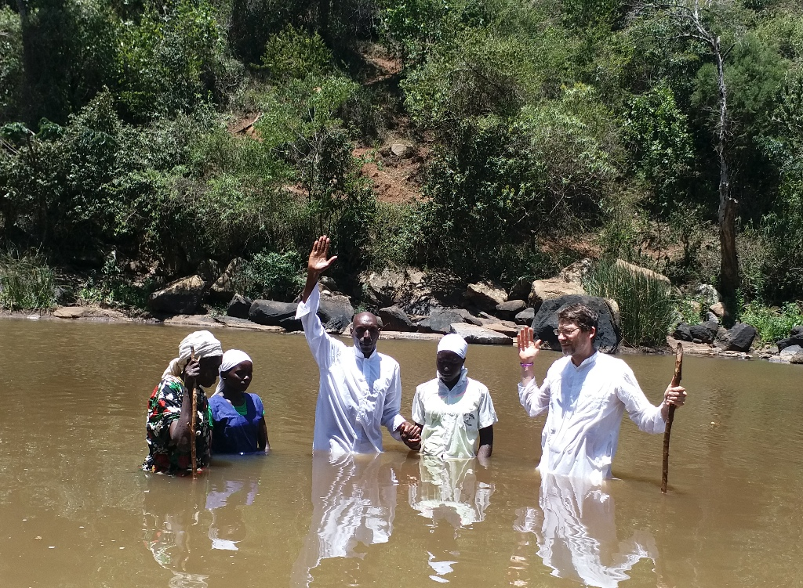
While I was there I was invited to attend the end of year celebrations at a primary government school and at a larger government high school. They invited me to speak at both functions. At the primary school I talked about why we have seven days in a week and the Ten Commandments and at the larger high school I spoke about King Soloman and wisdom and knowledge. At the larger function they were doing many songs, dances and giving awards to high scoring teachers. They gave the top teacher a cow and others received a goat; over 2000 people were in attendance. After my talk which was translated into Kalenjin by one of Pastor Wilsons Assembly members several people contacted the translator and asked me to come visit their houses and tell them more about this faith of Yahweh, but I was only there for about five days and could not do much visiting.
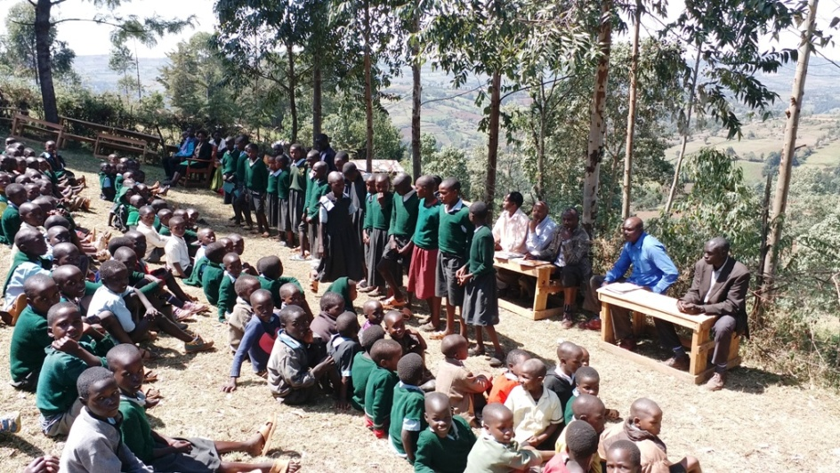

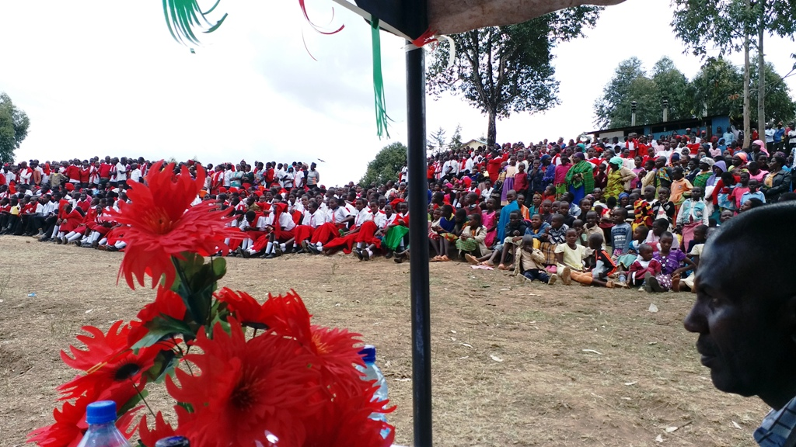
While I was speaking I used the Name of Yahweh and one man in the crowd was from the Assemblies of Yahweh that are associated with Bethel, Pennsylvania and he invited me to come to his Assembly which I did as I was leaving that area. I met briefly with them and just talked with the elders of the Assembly.
1st -5th grade school
During the meetings of the Sabbath day and then the New Moon day on Sunday the people would do a lot of dancing and singing. The floors where we were meeting were only earth dust floors. So as the people were dancing they would have to keeping pouring and sprinkling water on the floor to keep the dust down. This congregation had never kept the New Moon meetings before and as this was the first New Moon of the year for them, it was a special occasion. After blowing the Shofar and starting the meeting one pastor of our faith, named Carlos, stood up and told the people in English “Brother has just told us about the new moon and we have seen it, I want all of you to get up and dance and celebrate.” The people were very happy to comply and soon they were sprinkling more water on the floor. They had an Electric keyboard that they were running with the battery power and they would play nice music that the people would sing and dance to.
High School Students, Bomet, Kenya
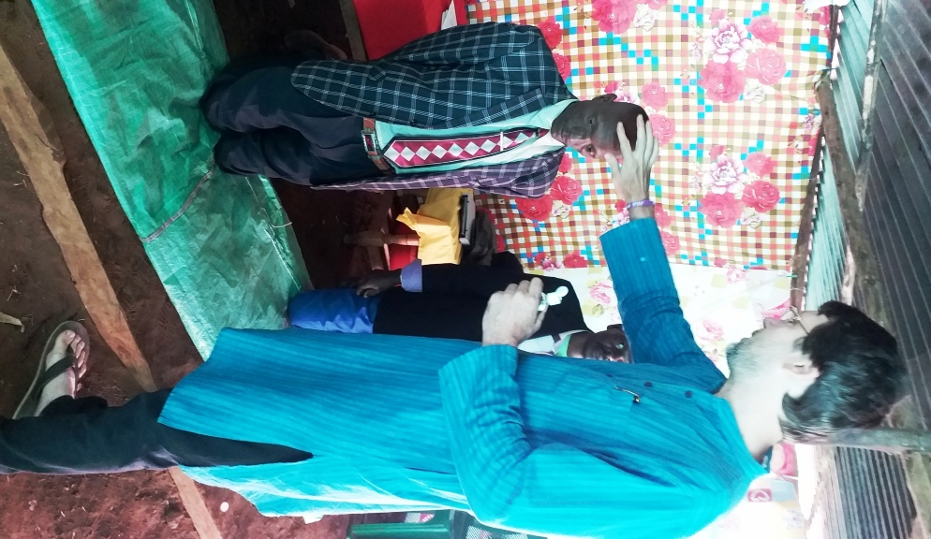
While there a pastor named Kibet from another place called Kericho came to see me. He told me of the good work going forward for Yahweh in that area and how br. Dwayne Wilson from Reach for Yahweh International Ministries had helped them construct a prayer hall. During my time in the Bomet mountainous area 12 people took immersion and I ordained Pastor Wilson Koech as an Elder in the name of Yahshua Messiah.
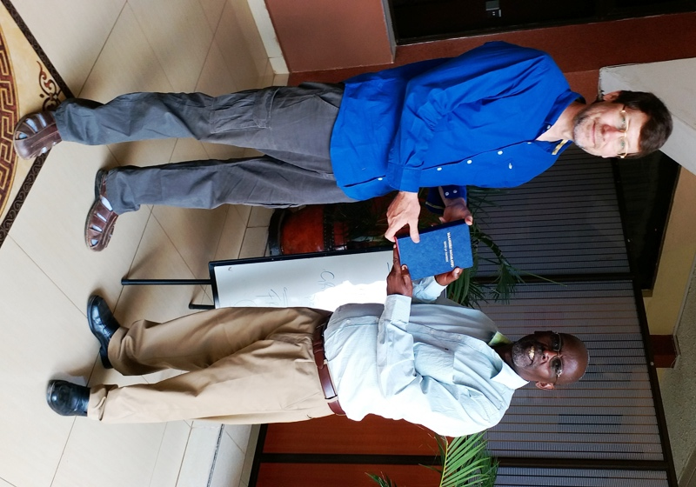
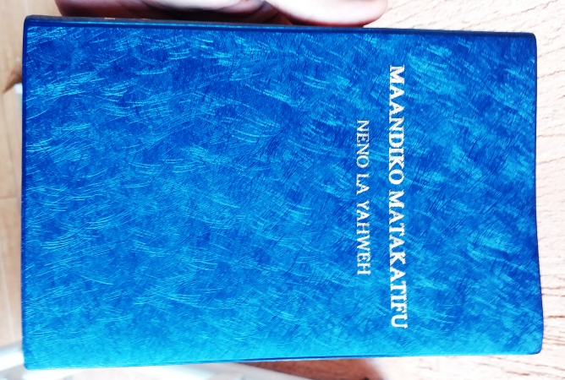
Elder Kihara gifting me a copy of the Sacred Name Swahili Bible that he helped translate
On Monday April 8 I headed back to Nairobi to meet with a longtime Pastor of the Sacred Name faith named Peter Kihara. On April 8 evening I met Elder Peter in Nairobi and visited him in his house and he paid my lodging for the two days I stayed in Nairobi before leaving on April 10. Elder Peter took me to see a few of his Assembly members and his prayer hall in an area of Nairobi called Zimmerman. Peter also showed me a Sacred Name translation of the Biblical Scriptures into the language of Swahili that he over saw. This copy he has used to promote our faith in not only Kenya but also Uganda, Tanzania, Rwanda and Sudan as Swahili speaking people are in all those countries as well.
There was one doctrinal issue of dispute that I encountered in Kenya. Before I came to Kenya I had asked Pastor Wilson Koech to contact Elder Peter Kihara and take immersion in Yahshua Messiah Name by Peter. But Wilson refused as he said Peter was immersed in Church of God in Jesus Name. With the distance and communication problems I was not able in India to fully determine the situation. So being that I had wanted to visit Kenya for many years and also because I had developed a good relation with Pastor Wilson and he was urgently requesting me for doing a “proper immersion” for him before Passover, I decided to visit Kenya at this time.
After spending some time with Elder Kihara and seeing the various good works he is involved with, I was convinced of his sincerity in serving Yahweh. So I inquired about his immersion and he told me that it is true he was immersed in the Church of God but that the group he was a member of used the name Yahshua Messiah. He said that they did not use the Name of Yahweh but that the elder that immersed him did immerse him in the name of Yahshua Messiah. Peter said that elder was still alive and he even offered to take me to him if I wanted. Peter also told me that if anyone was immersed in the name of Jesus Christ and wanted to join their Assemblies that they did require immersion in the name of Yahshua Messiah before they would accept them as a member.
Wilson Koech’s mother tongue is Kalenjin and Peters is Swahili and they are from different societal communities so there could have been some difficulties in proper communications between them. I explained to Wilson Koech about what I had learned from Peter Kihara concerning his immersion, but Wilson still did not accept Peter’s immersion as he said the man that immersed Peter was not immersed in the name of Yahshua Messiah himself. Peter confirmed to me that this was true. Wilson then urged the question upon me as to whether we should accept immersion from a man who was not immersed in the name of Yahshua Messiah himself. At the time I could not give Wilson a proper answer. I know that situations will vary and that the same answer cannot apply to all situations. But I wonder if the first people in recent times in last 100 years or so that started proclaiming the Names of Yahweh and Yahshua were ever immersed in the Name of Yahshua Messiah themselves? If they were the first people to use the Names after many hundreds of years of misuse, who would there be to do the first immersion in the Name of Yahshua Messiah? I generally believe that whoever immerses us should also be immersed in the Name of Yahshua Messiah himself but who would there be to immerse people like CO Dodd, AB Traina, Jacob O. Meyers etc…many years ago? I am open to enlightenment any can give on this issue.
While I was in Kenya I learned that it is the custom to circumcise the boys at about the age of 13. This is big ceremony in a young boy’s life and it is symbolic of leaving youth to become a man. I showed them how that according to Scripture the boys should be circumcised on the eighth day rather than at 13. I suggested to them that they have Bar Mitzvah ceremony instead and dedicate their boys as “sons of the commandments”. Many people in Kenya commented to me that the father of recent USA president Barak Obama, was born in Kenya. They further told me that Obama’s father was from the one tribe in Kenya that did not practice circumcision.
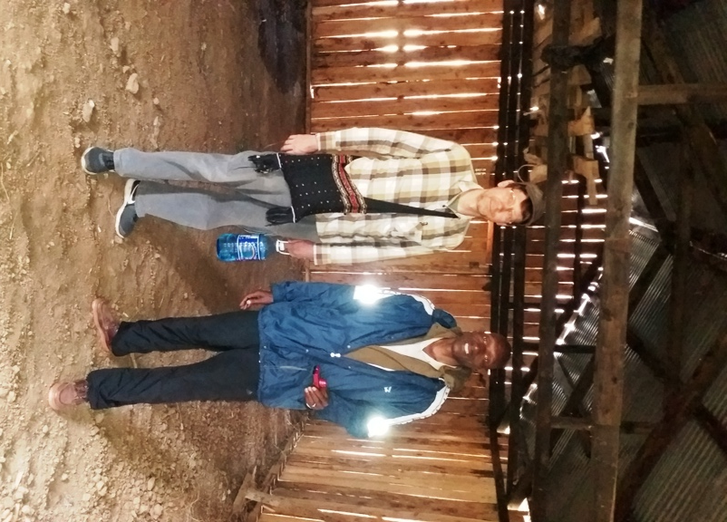
While in the village area with Pastor Wilson Koech he had constructed a small tin roof shed at his house where we had our meetings at, but he had bought a piece of land beside a road in an open place and started the construction of a prayer hall there. It is almost finished
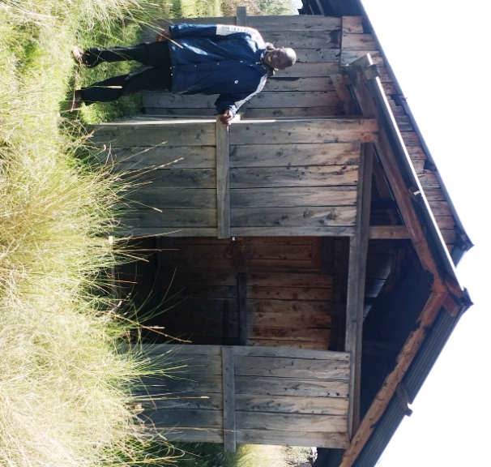
If any would like to help complete the windows and flooring, Pastor Koech needs some amount for that good work. And also for purchasing a generator for the congregation.
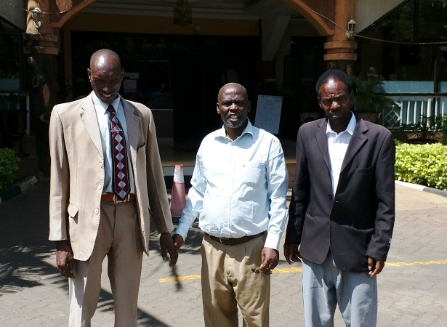
Pastor Wilson and Pastor Koech meeting outside the lodge I stayed at in Nairobi.

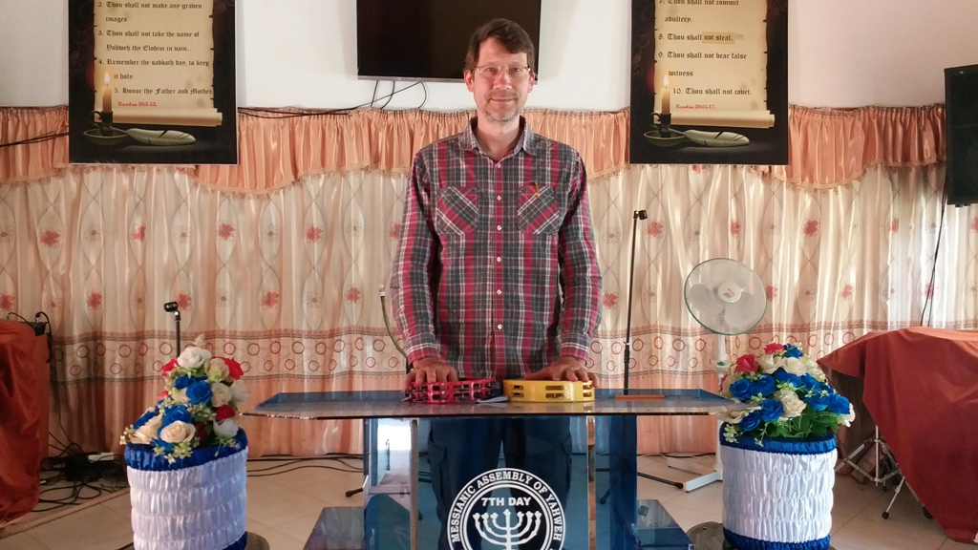
inside the Zimmerman prayer hall in Nairobi Kenya
Yahweh Pastors, Kibet(black) and Carlos(blue)
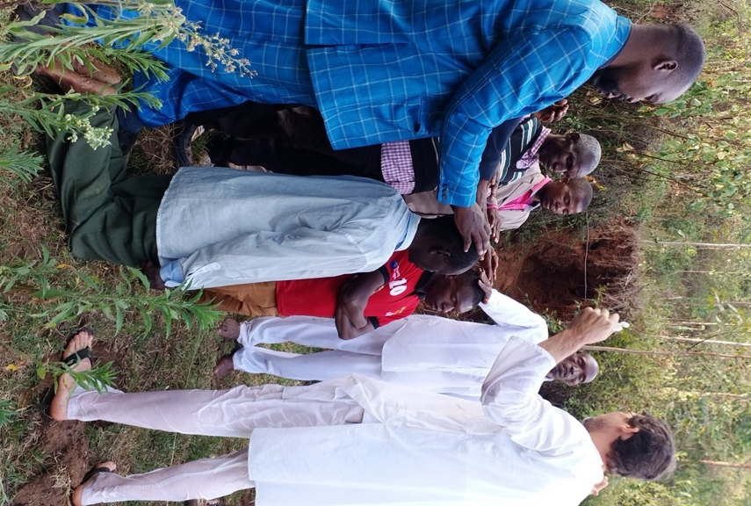
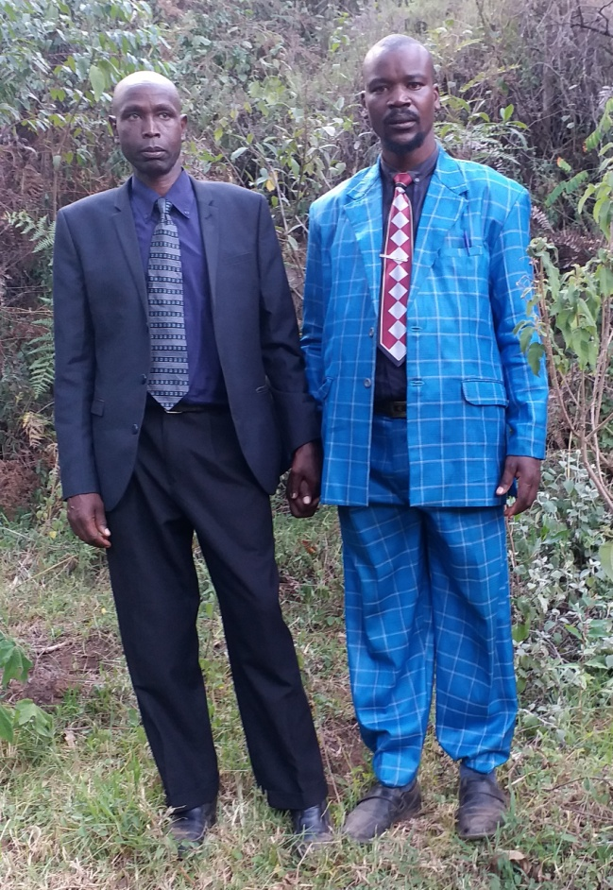
prayers of dedication and anointing after immersion

Prayer hall that Assemblies of Yahweh from Bethel, Penn. oversee.
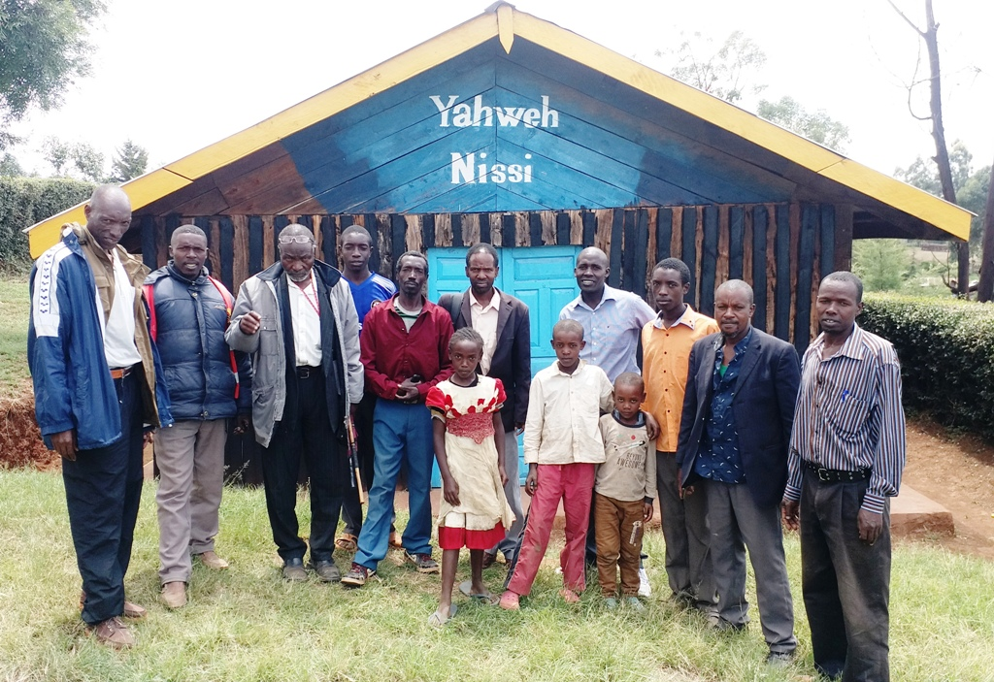
My trip to Kenya ended with me leaving by flight from Nairobi on April 10. As I started to leave I was informed that I was required by Government law to receive a yellow fever vaccination injection as I would not be allowed to enter India without a certificate showing that I had received the injection. Also, I was told, the airline would be fined if they did not verify that I had a certificate before leaving Kenya. Yellow fever is a disease spread by mosquitoes. The areas that I visited were cool and there were no mosquitoes, but anyways I obtained a certificate.
My short visit to Kenya was a blessed experience and look forward to visiting again sometime, maybe for keeping a festival with them. I would like to witness more to the people in the Kalinjin speaking areas.
Tony Suckla, May 5, 2019

